Class 3
Professor: Dr. Sungchul Hong
Reference:
Supply Chain Management Strategy, Planning, and Operation.
Sunil Chopra, Peter Meindl
Prentice Hall, 2001

Chapter Summary

Chapter 1: Understanding the Supply Chain

What is a supply chain?

Here is this book’s explanation of “supply chain”:

“A supply chain consists of all stages involved, directly or indirectly, in fulfilling a customer request. The supply chain not only includes the manufacturer and suppliers, but also transporters warehouses, retailers, and customers themselves.
A supply chain is dynamic and involves the constant flow of information, production and funds between different stages. Each stage of the supply chain performs different processes and interacts with other stages of the supply chain.”

A typical supply chain may involve a variety of stages such as:
- Customers
- Retailers
- Wholesalers/distributors
- Manufacturers
- Component/raw material suppliers.

Some supply chain has all the stages but some has less according to the business’s environment. Each stage could be a market or a hierarchy (please reference the first class material). In Internet supply chain management, the designer must analyze the business’s environment identifies these stages and types.

The Objective of a Supply Chain

In a supply chain, each stage generates some value. And the objective of every supply chain is to maximize the overall value generated. The value a supply chain generates is the difference between what the final product is worth to the customer and the effort the supply chain expends in filling the customer’s request.

Supply chain profitability is the total profit to be shared across all supply chain stages not the single stage’s maximum profit. We must consider the entire chain’s profit. The higher the supply chain profitability, the more successful the supply chain.

I’m emphasizing this one more time “Supply chain management involves the management of flows between and among stages in a supply chain to maximize total profitability”.

Decision Phases in a Supply Chain

A Supply chain needs three phases to build. These phases are strategy or design phase, planning phase, and operation phase.

1) Supply chain strategy or design.
In this phase, we must consider how to structure the supply chain. Location, capacities of production and warehousing facilities will be considered in this phase too.

2) Supply chain planning
In this phase, companies define a set of operating policies that govern short-term operations. They collect data and produce market and inventory level forecast. And they decide whether they need subcontract some of manufacturing or not in this phase.

3) Supply chain operation
In this phase companies make decisions regarding individual customer orders. Then, allocate individual orders to inventory or production. And they also manage shipments, delivery and schedules of trucks.

Process View of a Supply Chain

A supply chain is a sequence of processes (please reference the first class material) and flows that take place within and between different supply chain stages and combine to fill a customer need for a product. There are different views of this process:

Cycle view: The processes in a supply chain are divided into a series of cycles, each performed at the interface between two successive stages of a supply chain.

Cycle View of Supply Chain Process has following cycles

- Customer order cycle
- Replenishment cycle (at retailer/distributor)
- Manufacturing cycle (distributor/manufacturer)
- Procurement cycle (manufacturer/supplier )

The information flows from top to bottom and the products flow from bottom to top.
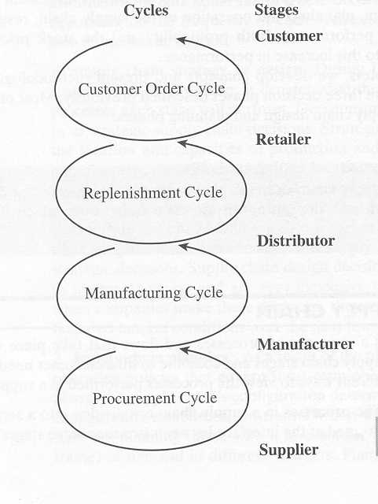
In the customer order cycle, there are processes performing customer order cycle.
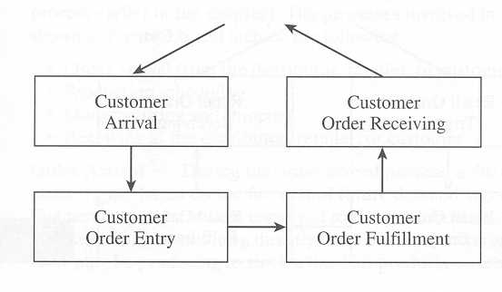
Customer Order Cycle

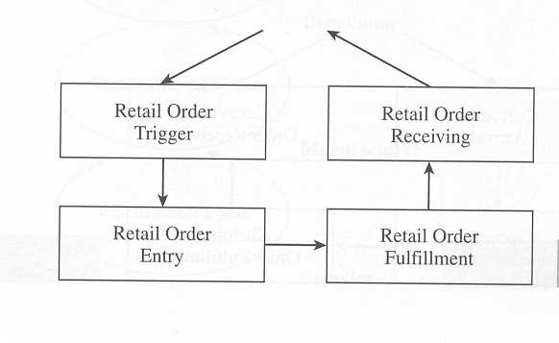
Replenishment Cycle

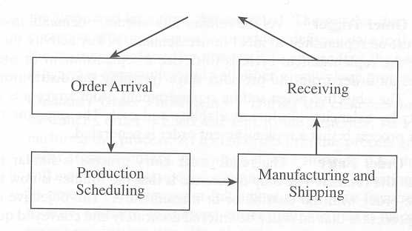
Manufacturing Cycle

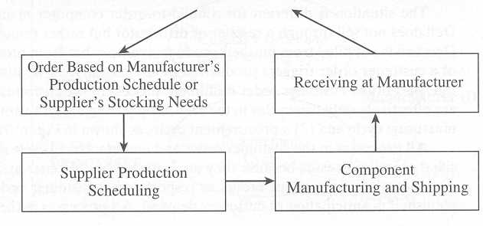
Procurement Cycle

2) Push/Pull view: The processes in a supply chain are divided into two categories depending on whether they are executed in response to a customer order or in anticipation of customer orders. Pull processes are initiated by a customer order, and push processes are initiated and performed in anticipation of customer orders. The pull process works well with a custom ordering as the push process works well with mass production.

Some supply chain has both push and pull in its chain and we can identify 2) Push/Pull view: The processes in a supply chain are divided into two categories depending on whether they are executed in response to a customer order or in anticipation of customer orders. Pull processes are initiated by a customer order, and push processes are initiated and performed in anticipation of customer orders. The pull process works well with a custom ordering as the push process works well with mass production.

this push/pull process boundary.
Here is an example of LL Beans supply chain. The customer order cycle is a pull process and replenishment, manufacturing and procurement cycles are push process.
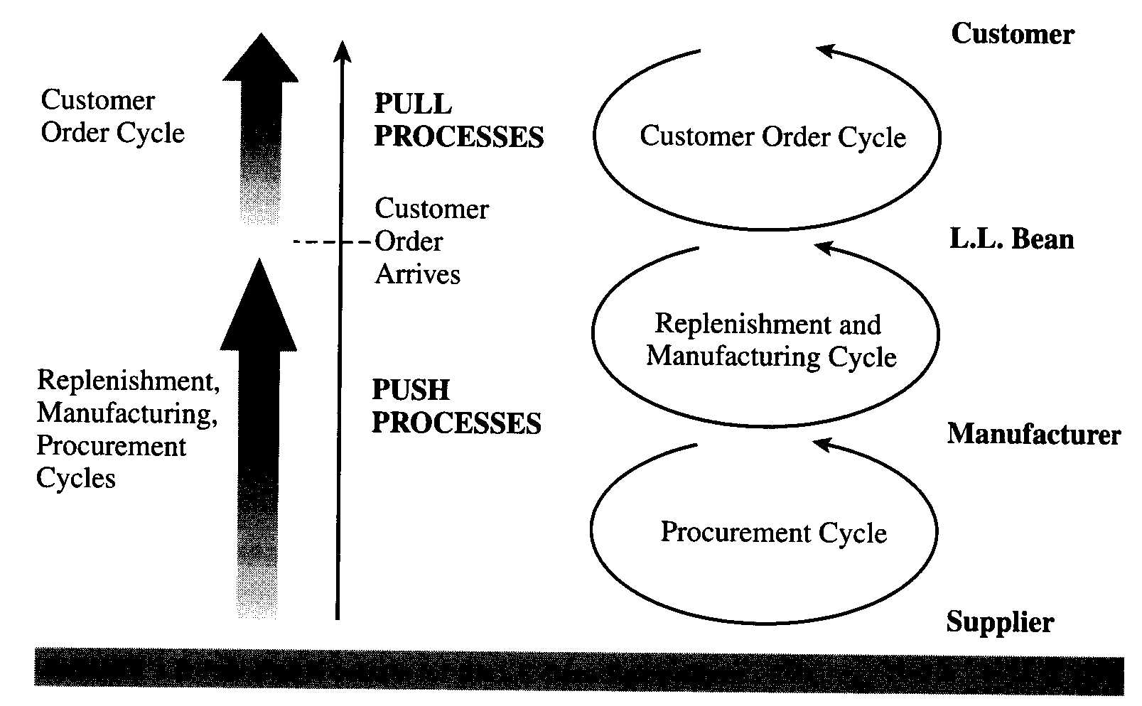

The Dell Computer’s Supply Chain Example

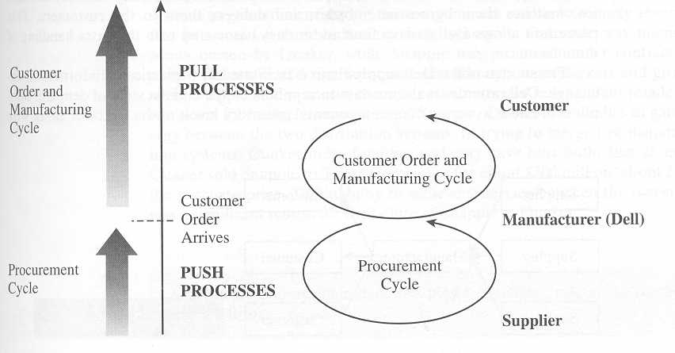
In this company, the customer order and manufacturing cycles are pull process and only the procurement cycle is push process.

The Importance of Supply Chain Flows

There is a close connection between the design and management of supply chain flows and the success of a supply chain.

e.g.) Dell has only 10 days of inventory contrast to other pc makers of 80 to 100 days. The success of the Dell supply chain is facilitated by sophisticated information exchange. (Customized web pages) and outsourcing.

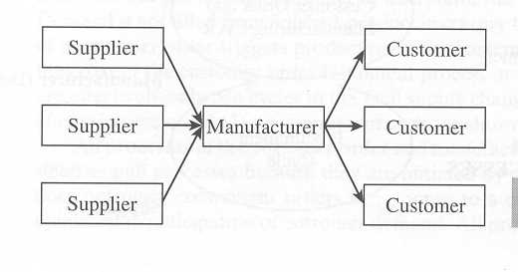
Dell Computer’s Supply Chain Stages

